Задача 1. Классификация изображений рукописных цифр

Набор данных: MNIST.

Предварительная обработка: масштабирование пикселей, разделение данных на обучение и тестирование.

Модели: логистическая регрессия, SVM, случайный лес, градиентный бустинг, нейронные сети.

Сравнение модели: точность, матрица ошибок, ROC-кривые.

Изучение и подбор гиперпараметров: GridSearchCV или RandomizedSearchCV.

Визуализация: отображение изображений, важности признаков или активаций нейронной сети.

import numpy as np

import pandas as pd

import matplotlib.pyplot as plt

import seaborn as sns

from sklearn import datasets

from sklearn.model_selection import train_test_split, GridSearchCV

from sklearn.preprocessing import StandardScaler

from sklearn.linear_model import LogisticRegression

from sklearn.svm import SVC

from sklearn.ensemble import RandomForestClassifier, GradientBoostingClassifier

from sklearn.neural_network import MLPClassifier

from sklearn.metrics import accuracy_score, confusion_matrix, roc_curve, auc

wine = datasets.load_wine()

X = pd.DataFrame(wine.data, columns=wine.feature_names)

y = pd.Series(wine.target)

scaler = StandardScaler()

X = scaler.fit_transform(X)

X_train, X_test, y_train, y_test = train_test_split(X, y, test_size=0.2, random_state=42)

log_reg = LogisticRegression(max_iter=1000)

log_reg.fit(X_train, y_train)

y_pred_log_reg = log_reg.predict(X_test)

accuracy_log_reg = accuracy_score(y_test, y_pred_log_reg)

svm = SVC(kernel='linear', probability=True)

svm.fit(X_train, y_train)

y_pred_svm = svm.predict(X_test)

accuracy_svm = accuracy_score(y_test, y_pred_svm)

rf = RandomForestClassifier(n_estimators=100)

rf.fit(X_train, y_train)

y_pred_rf = rf.predict(X_test)

accuracy_rf = accuracy_score(y_test, y_pred_rf)

gb = GradientBoostingClassifier(n_estimators=100)

gb.fit(X_train, y_train)

y_pred_gb = gb.predict(X_test)

accuracy_gb = accuracy_score(y_test, y_pred_gb)

mlp = MLPClassifier(hidden_layer_sizes=(100,), max_iter=1000)

mlp.fit(X_train, y_train)

y_pred_mlp = mlp.predict(X_test)

accuracy_mlp = accuracy_score(y_test, y_pred_mlp)

print(f"Accuracy - Logistic Regression: {accuracy_log_reg:.4f}")

print(f"Accuracy - SVM: {accuracy_svm:.4f}")

print(f"Accuracy - Random Forest: {accuracy_rf:.4f}")

print(f"Accuracy - Gradient Boosting: {accuracy_gb:.4f}")

print(f"Accuracy - MLP: {accuracy_mlp:.4f}")

cm_log_reg = confusion_matrix(y_test, y_pred_log_reg)

plt.figure(figsize=(8, 6))

sns.heatmap(cm_log_reg, annot=True, fmt="d", cmap="Blues", xticklabels=wine.target_names, yticklabels=wine.target_names)

plt.title('Confusion Matrix - Logistic Regression')

plt.xlabel('Predicted')

plt.ylabel('True')

plt.show()

from sklearn.preprocessing import label_binarize

y_test_bin = label_binarize(y_test, classes=[0, 1, 2])

y_score_log_reg = log_reg.predict_proba(X_test)

fpr = {}

tpr = {}

roc_auc = {}

for i in range(3):

    fpr[i], tpr[i], _ = roc_curve(y_test_bin[:, i], y_score_log_reg[:, i])

    roc_auc[i] = auc(fpr[i], tpr[i])

plt.figure()

colors = ['blue', 'red', 'green']

for i, color in enumerate(colors):

    plt.plot(fpr[i], tpr[i], color=color, lw=2, label=f'Class {i} (area = {roc_auc[i]:.2f})')

plt.plot([0, 1], [0, 1], color='navy', lw=2, linestyle='--')

plt.xlim([0.0, 1.0])

plt.ylim([0.0, 1.05])

plt.xlabel('False Positive Rate')

plt.ylabel('True Positive Rate')

plt.title('Receiver Operating Characteristic - Logistic Regression')

plt.legend(loc="lower right")

plt.show()

param_grid = {'C': [0.01, 0.1, 1, 10], 'solver': ['liblinear', 'saga']}

grid_search = GridSearchCV(LogisticRegression(max_iter=1000), param_grid, cv=3)

grid_search.fit(X_train, y_train)

print("Best parameters for Logistic Regression:", grid_search.best_params_)

importances = rf.feature_importances_

indices = np.argsort(importances)[::-1]

plt.figure(figsize=(10, 6))

plt.bar(range(X.shape[1]), importances[indices], align="center")

plt.xticks(range(X.shape[1]), np.array(wine.feature_names)[indices], rotation=90)

plt.title("Feature Importances (Random Forest)")

plt.show()

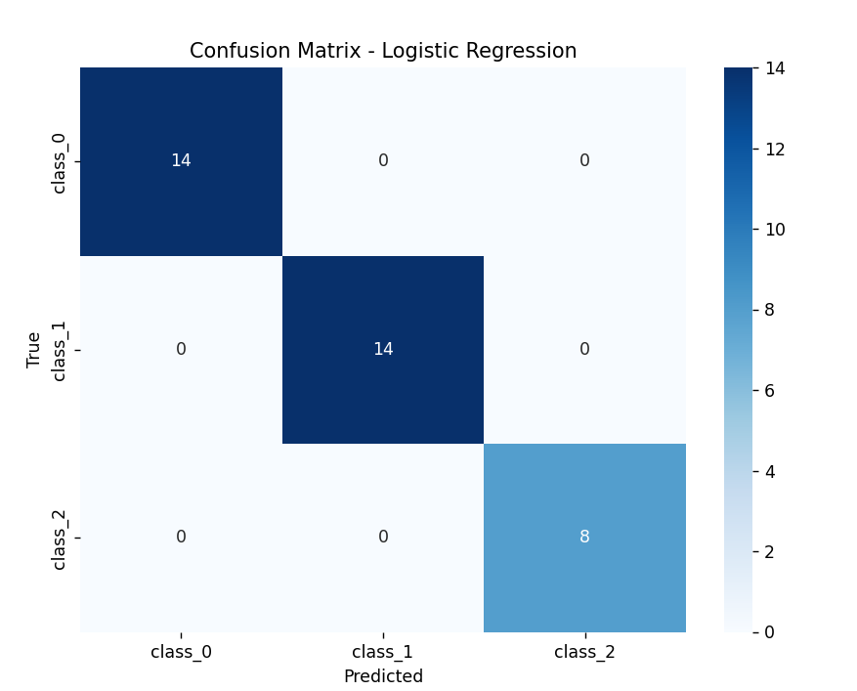

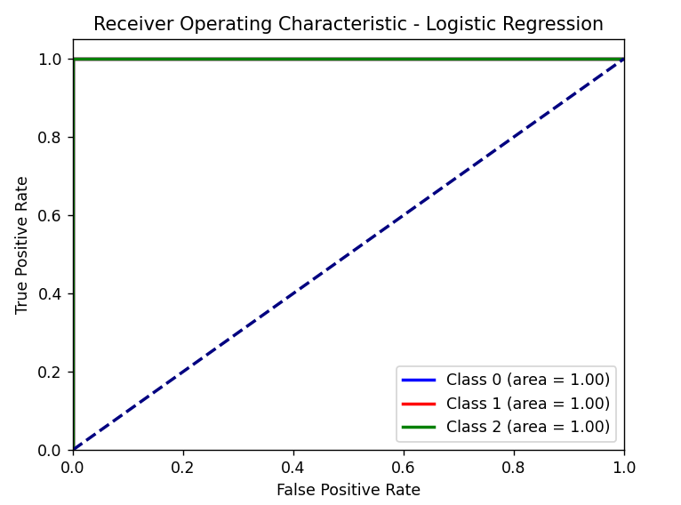

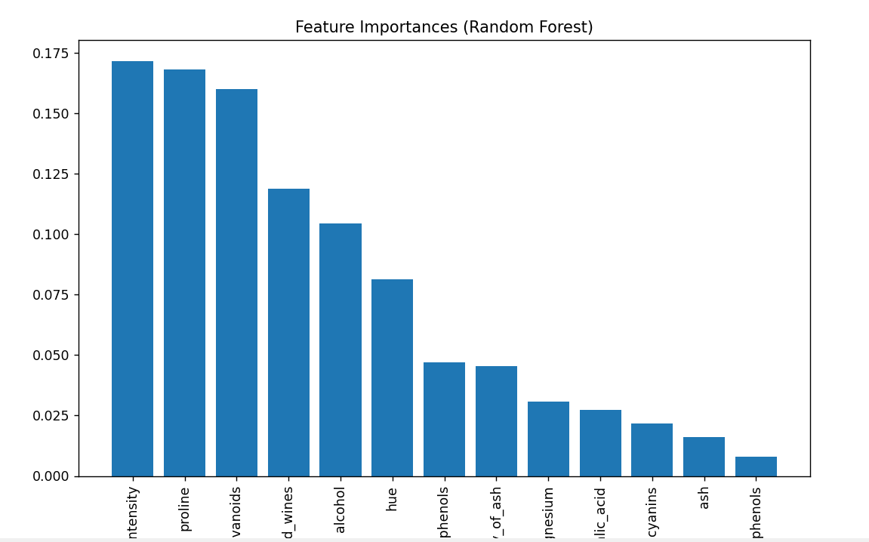

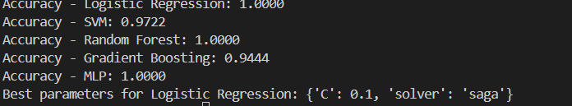

Задача 2. Определение мошенничества с кредитными картами

Набор данных: Credit Card Fraud Detection dataset на Kaggle.

Предварительная обработка: масштабирование, обработка несбалансированных данных.

Модели: логистическая регрессия, SVM, случайный лес, градиентный бустинг, нейронные сети.

Сравнение моделей: точность, полнота, ROC-кривые.

Изучение и подбор гиперпараметров: GridSearchCV или RandomizedSearchCV.

Визуализация: важности признаков, ROC-кривые.

import numpy as np

import matplotlib.pyplot as plt

import seaborn as sns

from sklearn.datasets import load_wine

from sklearn.model_selection import train_test_split, GridSearchCV

from sklearn.linear_model import LogisticRegression

from sklearn.svm import SVC

from sklearn.ensemble import RandomForestClassifier, GradientBoostingClassifier

from sklearn.neural_network import MLPClassifier

from sklearn.metrics import accuracy_score, confusion_matrix, roc_curve, roc_auc_score, RocCurveDisplay

# Загрузка данных

wine = load_wine()

X, y = wine['data'], wine['target']

# Разделение на тренировочные и тестовые данные

X_train, X_test, y_train, y_test = train_test_split(X, y, test_size=0.2, random_state=42)

# Словарь для моделей и их параметров

models = {

    'Logistic Regression': LogisticRegression(max_iter=1000, multi_class='ovr'),

    'SVM': SVC(probability=True),

    'Random Forest': RandomForestClassifier(),

    'Gradient Boosting': GradientBoostingClassifier(),

    'Neural Network': MLPClassifier(max_iter=1000)

}

# Обучение и оценка моделей

results = {}

for name, model in models.items():

    model.fit(X_train, y_train)

    y_pred = model.predict(X_test)

    accuracy = accuracy_score(y_test, y_pred)

    roc_auc = roc_auc_score(

        y_test, model.predict_proba(X_test), multi_class='ovr'

    ) if hasattr(model, 'predict_proba') else None

    results[name] = {

        'accuracy': accuracy,

        'confusion_matrix': confusion_matrix(y_test, y_pred),

        'roc_auc': roc_auc

    }

# Сравнение точности моделей

for name, metrics in results.items():

    roc_auc_str = f", ROC AUC = {metrics['roc_auc']:.4f}" if metrics['roc_auc'] is not None else ""

    print(f"{name}: Accuracy = {metrics['accuracy']:.4f}{roc_auc_str}")

# Визуализация матрицы ошибок

def plot_confusion_matrix(cm, title='Confusion Matrix'):

    plt.figure(figsize=(8, 6))

    sns.heatmap(cm, annot=True, fmt='d', cmap='Blues', cbar=False)

    plt.title(title)

    plt.ylabel('True label')

    plt.xlabel('Predicted label')

    plt.show()

# Пример визуализации матрицы ошибок для SVM

plot_confusion_matrix(results['SVM']['confusion_matrix'], title='SVM Confusion Matrix')

# ROC-кривые

plt.figure(figsize=(10, 7))

for name, model in models.items():

    if hasattr(model, 'predict_proba'):

        for i in range(len(wine.target_names)):

            fpr, tpr, _ = roc_curve(y_test == i, model.predict_proba(X_test)[:, i])

            plt.plot(fpr, tpr, label=f'{name} - Class {i}')

plt.plot([0, 1], [0, 1], 'k--')

plt.xlabel('False Positive Rate')

plt.ylabel('True Positive Rate')

plt.title('ROC Curves')

plt.legend()

plt.show()

# Подбор гиперпараметров (пример для SVM)

param_grid = {'C': [0.1, 1, 10, 100], 'gamma': ['scale', 'auto']}

grid_search = GridSearchCV(SVC(probability=True), param_grid, cv=3, scoring='accuracy')

grid_search.fit(X_train, y_train)

print(f"Best parameters for SVM: {grid_search.best_params_}")

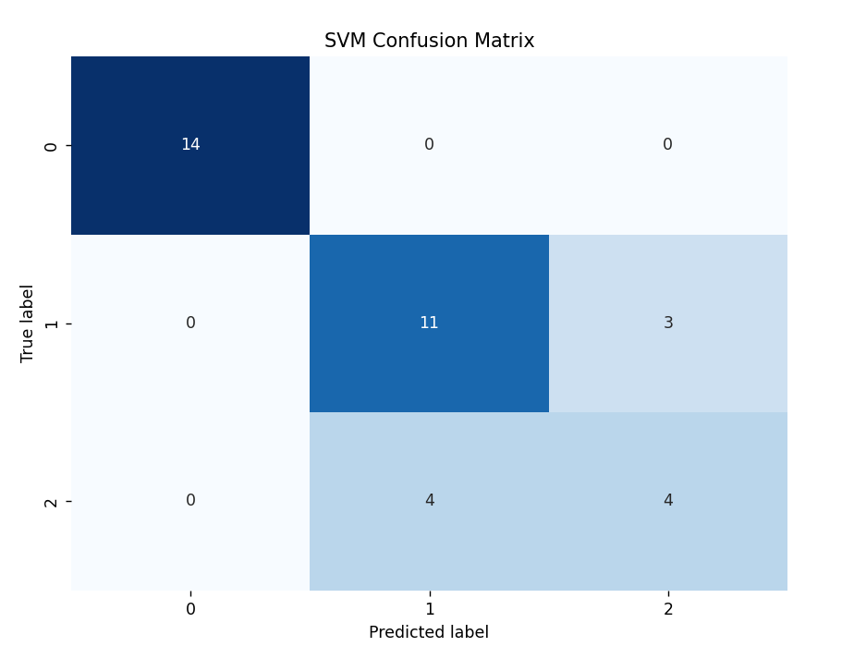

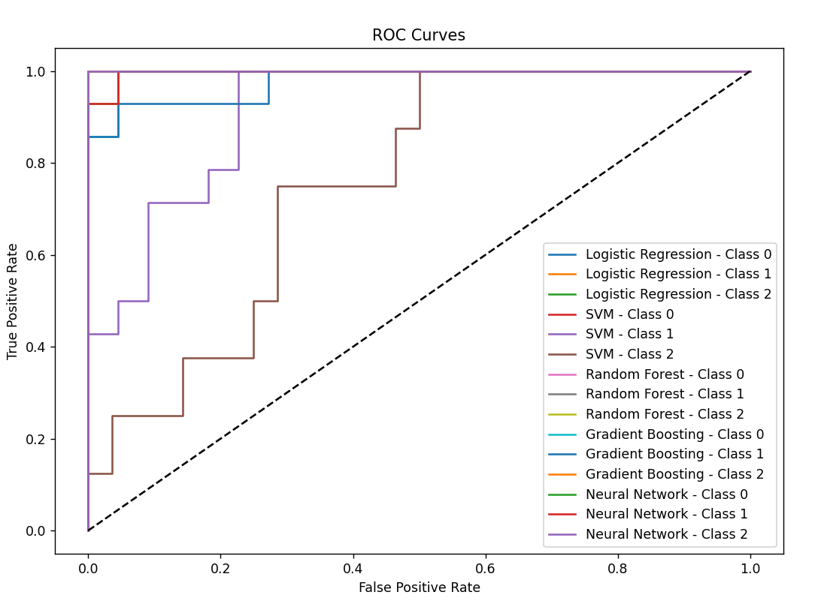

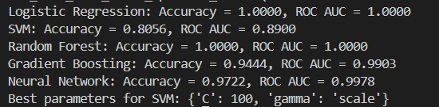

Задача 3. Классификация рака молочной железы

Набор данных: Breast Cancer Wisconsin (Diagnostic).

Предварительная обработка: масштабирование, разделение данных на обучающие и тестовые.

Модели: логистическая регрессия, SVM, решающие деревья, случайный лес, градиентный бустинг.

Сравнение моделей: точность, матрица ошибок, ROC-кривые.

Изучение и подбор гиперпараметров: GridSearchCV или RandomizedSearchCV.

Визуализация: важности признаков, корреляционная матрица.

import pandas as pd

from sklearn.datasets import load_breast_cancer

from sklearn.model_selection import train_test_split, GridSearchCV

from sklearn.preprocessing import StandardScaler

from sklearn.linear_model import LogisticRegression

from sklearn.svm import SVC

from sklearn.tree import DecisionTreeClassifier

from sklearn.ensemble import RandomForestClassifier, GradientBoostingClassifier

from sklearn.metrics import accuracy_score, confusion_matrix, roc_curve, roc_auc_score

import matplotlib.pyplot as plt

import seaborn as sns

data = load_breast_cancer()

X = data.data

y = data.target

X_train, X_test, y_train, y_test = train_test_split(X, y, test_size=0.2, random_state=42)

scaler = StandardScaler()

X_train_scaled = scaler.fit_transform(X_train)

X_test_scaled = scaler.transform(X_test)

models = {

    'Logistic Regression': LogisticRegression(max_iter=1000),

    'SVM': SVC(probability=True),

    'Decision Tree': DecisionTreeClassifier(),

    'Random Forest': RandomForestClassifier(),

    'Gradient Boosting': GradientBoostingClassifier()

}

accuracy = {}

roc_auc = {}

for name, model in models.items():

    model.fit(X_train_scaled, y_train)

    y_pred = model.predict(X_test_scaled)

    accuracy[name] = accuracy_score(y_test, y_pred)

    roc_auc[name] = roc_auc_score(y_test, model.predict_proba(X_test_scaled)[:, 1])

print("Точность моделей:")

for name, score in accuracy.items():

    print(f"{name}: {score:.4f}")

print("\nROC AUC для моделей:")

for name, score in roc_auc.items():

    print(f"{name}: {score:.4f}")

for name, model in models.items():

    y_pred = model.predict(X_test_scaled)

    cm = confusion_matrix(y_test, y_pred)

    print(f"\nМатрица ошибок для {name}:")

    print(cm)

plt.figure(figsize=(10, 8))

for name, model in models.items():

    y_prob = model.predict_proba(X_test_scaled)[:, 1]

    fpr, tpr, _ = roc_curve(y_test, y_prob)

    plt.plot(fpr, tpr, label=f'{name} (AUC = {roc_auc[name]:.2f})')

plt.plot([0, 1], [0, 1], linestyle='--', color='gray')

plt.xlabel('False Positive Rate')

plt.ylabel('True Positive Rate')

plt.title('ROC Curve')

plt.legend()

plt.show()

param_grid_lr = {'C': [0.1, 1, 10], 'solver': ['liblinear', 'saga']}

grid_search_lr = GridSearchCV(LogisticRegression(), param_grid_lr, cv=5)

grid_search_lr.fit(X_train_scaled, y_train)

print(f"\nЛучшие гиперпараметры для логистической регрессии: {grid_search_lr.best_params_}")

rf_model = RandomForestClassifier()

rf_model.fit(X_train_scaled, y_train)

importances = rf_model.feature_importances_

indices = importances.argsort()

plt.figure(figsize=(10, 6))

plt.barh(range(len(importances)), importances[indices], align='center')

plt.yticks(range(len(importances)), [data.feature_names[i] for i in indices])

plt.title('Важности признаков (Random Forest)')

plt.show()

correlation_matrix = pd.DataFrame(X_train_scaled, columns=data.feature_names).corr()

plt.figure(figsize=(12, 10))

sns.heatmap(correlation_matrix, annot=True, cmap='coolwarm', fmt='.2f')

plt.title('Корреляционная матрица')

plt.show()



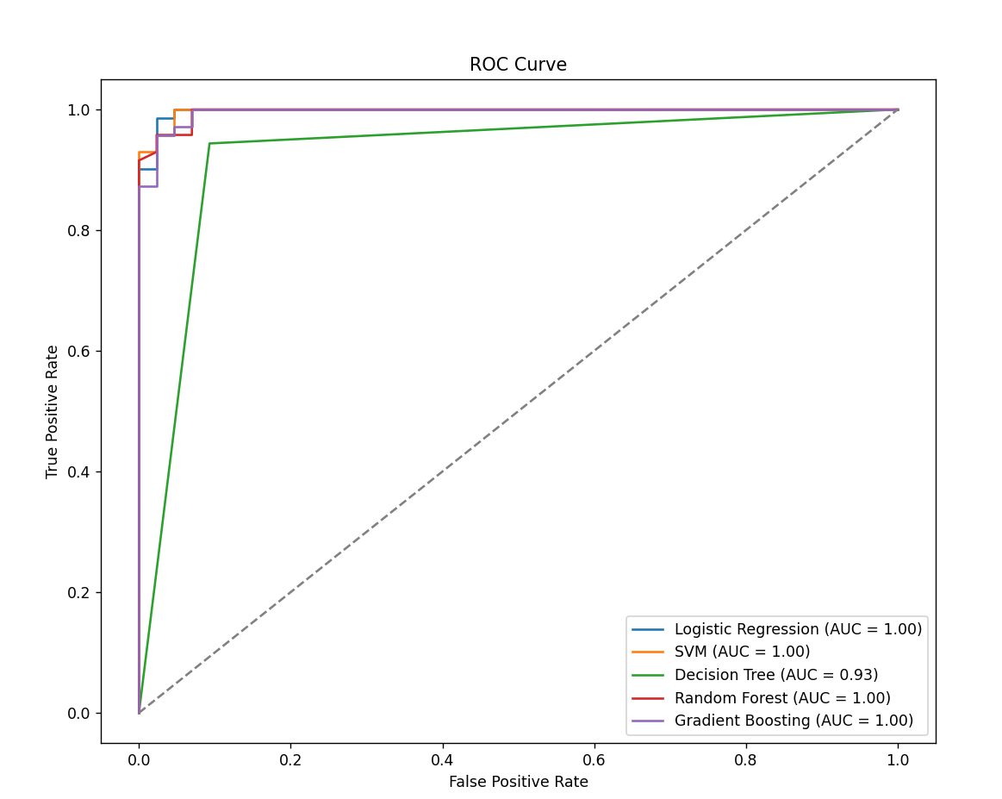

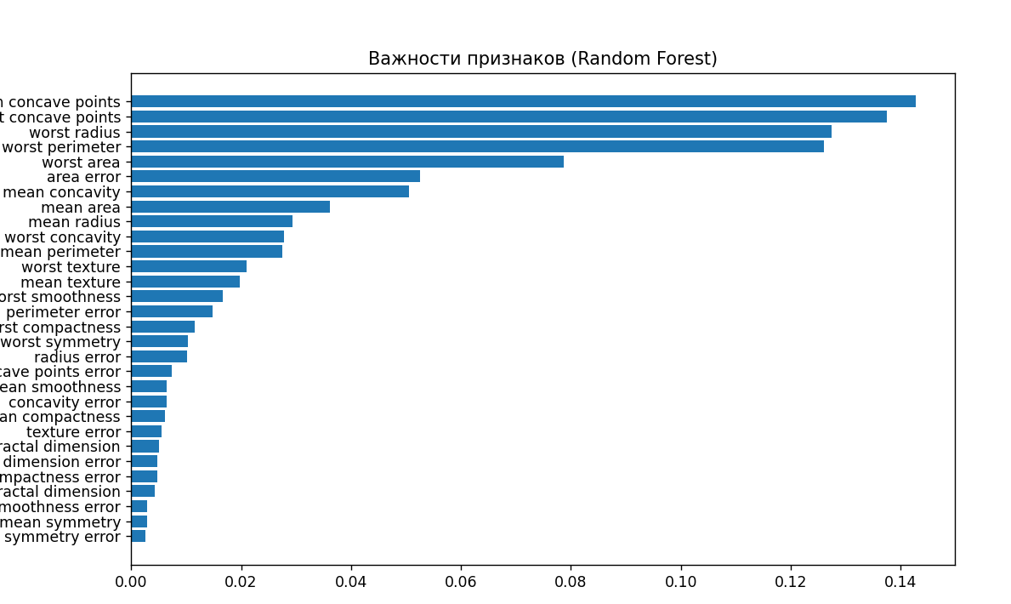

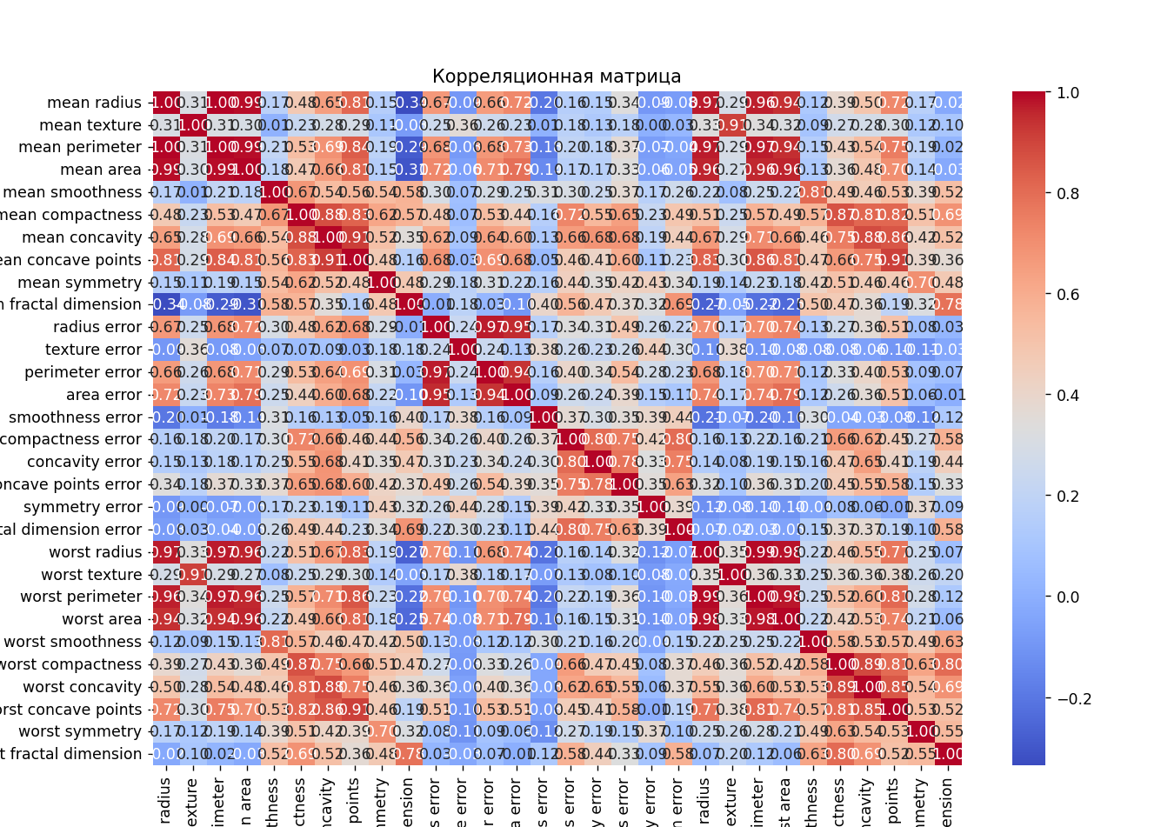

Задача 4. Спам-фильтрация для текстовых сообщений

Набор данных: SMS Spam Collection на Kaggle.

Предварительная обработка: векторизация текста, масштабирование, разделение данных на обучающие и тестовые.

Модели: логистическая регрессия, SVM, случайный лес, градиентный бустинг.

Сравнение моделей: точность, матрица ошибок, ROC-кривые.

Изучение и подбор гиперпараметров: GridSearchCV или RandomizedSearchCV.

Визуализация: важности признаков.

import pandas as pd

import numpy as np

import matplotlib.pyplot as plt

import seaborn as sns

from sklearn.model_selection import train_test_split, GridSearchCV, RandomizedSearchCV

from sklearn.feature_extraction.text import TfidfVectorizer

from sklearn.metrics import accuracy_score, confusion_matrix, classification_report, roc_curve, auc

from sklearn.linear_model import LogisticRegression

from sklearn.svm import SVC

from sklearn.ensemble import RandomForestClassifier, GradientBoostingClassifier

df = pd.read_csv("spam.csv", encoding='latin-1')

print(df.head())

print(df.info())

df = df[['v1', 'v2']]

df.columns = ['label', 'message']

df['label'] = df['label'].map({'ham': 0, 'spam': 1})

print(df['label'].value_counts())

X = df['message']

y = df['label']

vectorizer = TfidfVectorizer(stop_words='english', max_features=3000)

X_tfidf = vectorizer.fit_transform(X)

X_train, X_test, y_train, y_test = train_test_split(X_tfidf, y, test_size=0.2, random_state=42, stratify=y)

log_reg = LogisticRegression(max_iter=1000, random_state=42)

log_reg.fit(X_train, y_train)

y_pred_log = log_reg.predict(X_test)

svm = SVC(kernel='linear', probability=True, random_state=42)

svm.fit(X_train, y_train)

y_pred_svm = svm.predict(X_test)

rf = RandomForestClassifier(n_estimators=100, random_state=42)

rf.fit(X_train, y_train)

y_pred_rf = rf.predict(X_test)

gb = GradientBoostingClassifier(random_state=42)

gb.fit(X_train, y_train)

y_pred_gb = gb.predict(X_test)

def evaluate_model(y_true, y_pred, model_name):

    print(f"=== {model_name} ===")

    print(f"Accuracy: {accuracy_score(y_true, y_pred):.4f}")

    print(classification_report(y_true, y_pred))

    cm = confusion_matrix(y_true, y_pred)

    plt.figure(figsize=(6, 4))

    sns.heatmap(cm, annot=True, fmt='d', cmap='Blues', xticklabels=['Ham', 'Spam'], yticklabels=['Ham', 'Spam'])

    plt.title(f"Confusion Matrix: {model_name}")

    plt.xlabel('Predicted')

    plt.ylabel('True')

    plt.show()

evaluate_model(y_test, y_pred_log, "Logistic Regression")

evaluate_model(y_test, y_pred_svm, "SVM")

evaluate_model(y_test, y_pred_rf, "Random Forest")

evaluate_model(y_test, y_pred_gb, "Gradient Boosting")

def plot_roc_curves(models, X_test, y_test):

    plt.figure(figsize=(10, 8))

    for name, model in models.items():

        if hasattr(model, "predict_proba"):

            y_prob = model.predict_proba(X_test)[:, 1]

        else:

            y_prob = model.decision_function(X_test)

        fpr, tpr, _ = roc_curve(y_test, y_prob)

        roc_auc = auc(fpr, tpr)

        plt.plot(fpr, tpr, label=f"{name} (AUC = {roc_auc:.2f})")

    plt.plot([0, 1], [0, 1], 'k--')

    plt.xlabel("FPR")

    plt.ylabel("TPR")

    plt.title("ROC-кривые")

    plt.legend()

    plt.show()

models = {

    "Logistic Regression": log_reg,

    "SVM": svm,

    "Random Forest": rf,

    "Gradient Boosting": gb

}

plot_roc_curves(models, X_test, y_test)

param_grid_rf = {

    'n_estimators': [50, 100, 200],

    'max_depth': [None, 10, 20],

    'min_samples_split': [2, 5, 10]

}

grid_rf = GridSearchCV(RandomForestClassifier(random_state=42), param_grid_rf, cv=3)

grid_rf.fit(X_train, y_train)

print("Лучшие параметры для Random Forest:", grid_rf.best_params_)

param_dist_gb = {

    'n_estimators': [50, 100, 200],

    'learning_rate': [0.01, 0.1, 0.2],

    'max_depth': [3, 5, 10]

}

random_gb = RandomizedSearchCV(GradientBoostingClassifier(random_state=42), param_dist_gb, n_iter=10, cv=3, random_state=42)

random_gb.fit(X_train, y_train)

print("Лучшие параметры для Gradient Boosting:", random_gb.best_params_)

importances = rf.feature_importances_

indices = np.argsort(importances)[::-1]

top_features = 10

plt.figure(figsize=(12, 6))

plt.bar(range(top_features), importances[indices[:top_features]])

plt.xticks(range(top_features), np.array(vectorizer.get_feature_names_out())[indices[:top_features]], rotation=90)

plt.title("Важность признаков (Random Forest)")

plt.show()

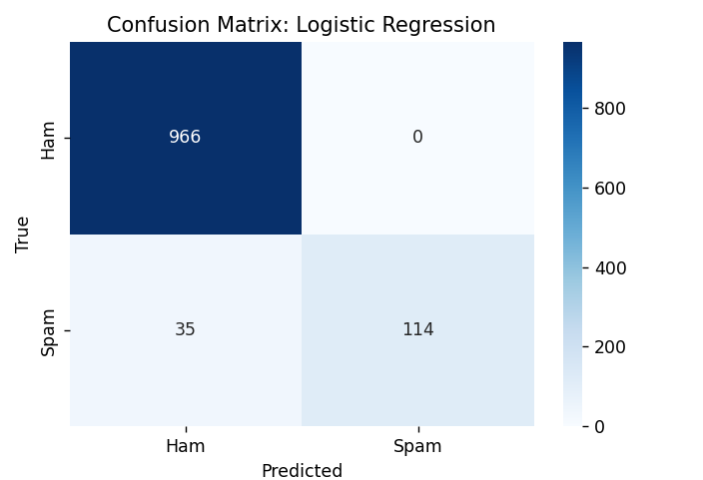

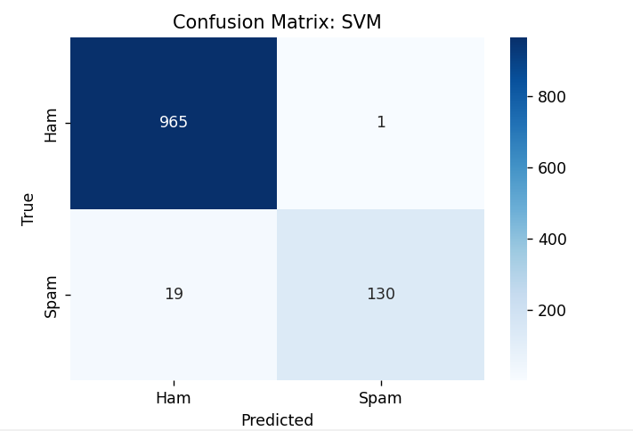

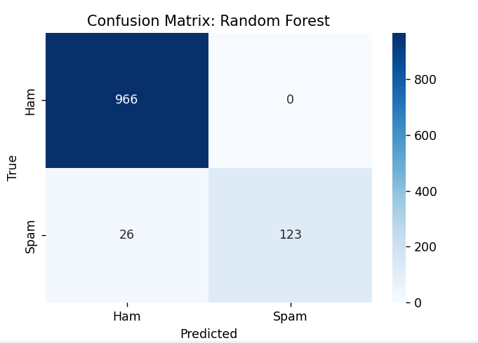

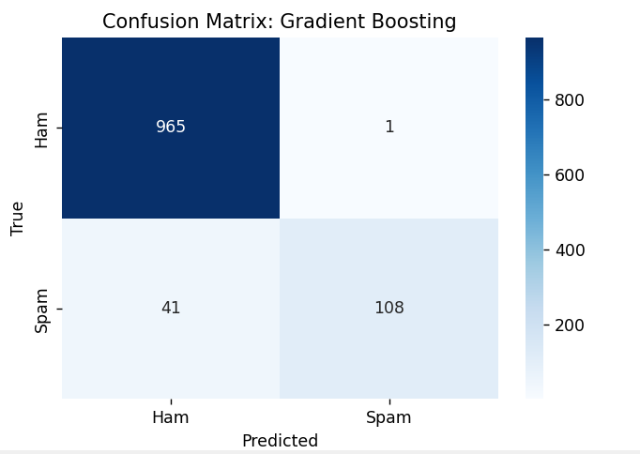

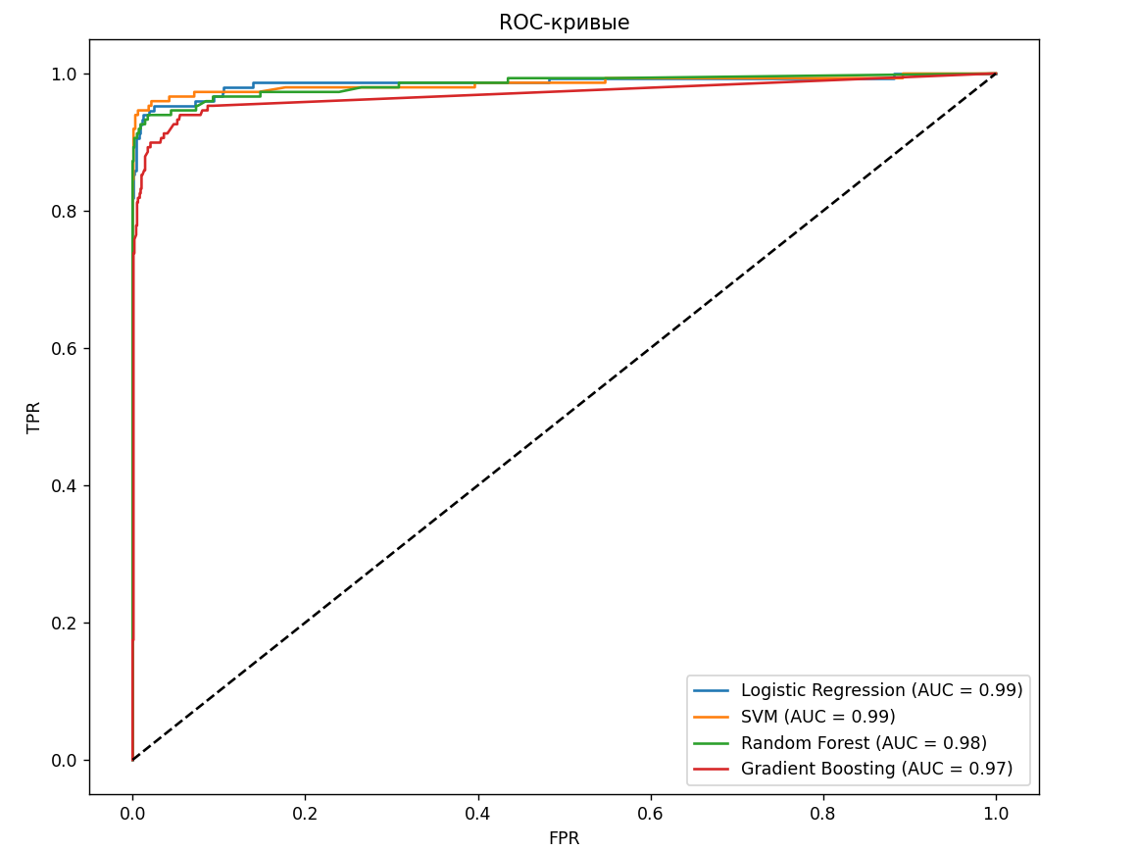

Задача 5. Классификация новостных статей

Набор данных: 20 Newsgroups dataset на sklearn.

Предварительная обработка: векторизация текста/TF-IDF, масштабирование, разделение данных на обучающие и тестовые.

Модели: логистическая регрессия, SVM, случайный лес, градиентный бустинг.

Сравнение моделей: точность, матрица ошибок.

Изучение и подбор гиперпараметров: GridSearchCV или RandomizedSearchCV.

Визуализация: важности признаков.

from sklearn.datasets import fetch_20newsgroups

from sklearn.model_selection import train_test_split, GridSearchCV

from sklearn.feature_extraction.text import TfidfVectorizer

from sklearn.linear_model import LogisticRegression

from sklearn.svm import SVC

from sklearn.ensemble import RandomForestClassifier, GradientBoostingClassifier

from sklearn.metrics import accuracy_score, confusion_matrix

import seaborn as sns

import matplotlib.pyplot as plt

import numpy as np

categories = None

data = fetch_20newsgroups(subset='all', categories=categories, remove=('headers', 'footers', 'quotes'))

X_train, X_test, y_train, y_test = train_test_split(data.data, data.target, test_size=0.2, random_state=42)

tfidf = TfidfVectorizer(max_features=5000, stop_words='english')

X_train_tfidf = tfidf.fit_transform(X_train)

X_test_tfidf = tfidf.transform(X_test)

models = {

    "Logistic Regression": LogisticRegression(max_iter=1000, random_state=42),

    "SVM": SVC(kernel='linear', random_state=42),

    "Random Forest": RandomForestClassifier(n_estimators=100, random_state=42),

    "Gradient Boosting": GradientBoostingClassifier(n_estimators=100, random_state=42)

}

results = {}

for model_name, model in models.items():

    model.fit(X_train_tfidf, y_train)

    y_pred = model.predict(X_test_tfidf)

    acc = accuracy_score(y_test, y_pred)

    results[model_name] = acc

    print(f"{model_name} Accuracy: {acc:.4f}")

def plot_confusion_matrix(y_true, y_pred, title):

    cm = confusion_matrix(y_true, y_pred)

    plt.figure(figsize=(10, 8))

    sns.heatmap(cm, annot=True, fmt='d', cmap='Blues', xticklabels=data.target_names, yticklabels=data.target_names)

    plt.title(title)

    plt.xlabel("Predicted")

    plt.ylabel("Actual")

    plt.show()

best_model_name = max(results, key=results.get)

best_model = models[best_model_name]

y_pred_best = best_model.predict(X_test_tfidf)

plot_confusion_matrix(y_test, y_pred_best, f"Confusion Matrix: {best_model_name}")

param_grid = {

    'C': [0.1, 1, 10],

    'penalty': ['l2']

}

grid = GridSearchCV(LogisticRegression(max_iter=1000, random_state=42), param_grid, cv=3, scoring='accuracy')

grid.fit(X_train_tfidf, y_train)

print(f"Best Parameters: {grid.best_params_}")

best_log_reg = grid.best_estimator_

if isinstance(best_model, RandomForestClassifier):

    feature_importances = best_model.feature_importances_

    indices = np.argsort(feature_importances)[-20:]

    feature_names = np.array(tfidf.get_feature_names_out())

    plt.figure(figsize=(10, 8))

    plt.barh(range(len(indices)), feature_importances[indices], align='center')

    plt.yticks(range(len(indices)), feature_names[indices])

    plt.title("Feature Importances")

    plt.show()

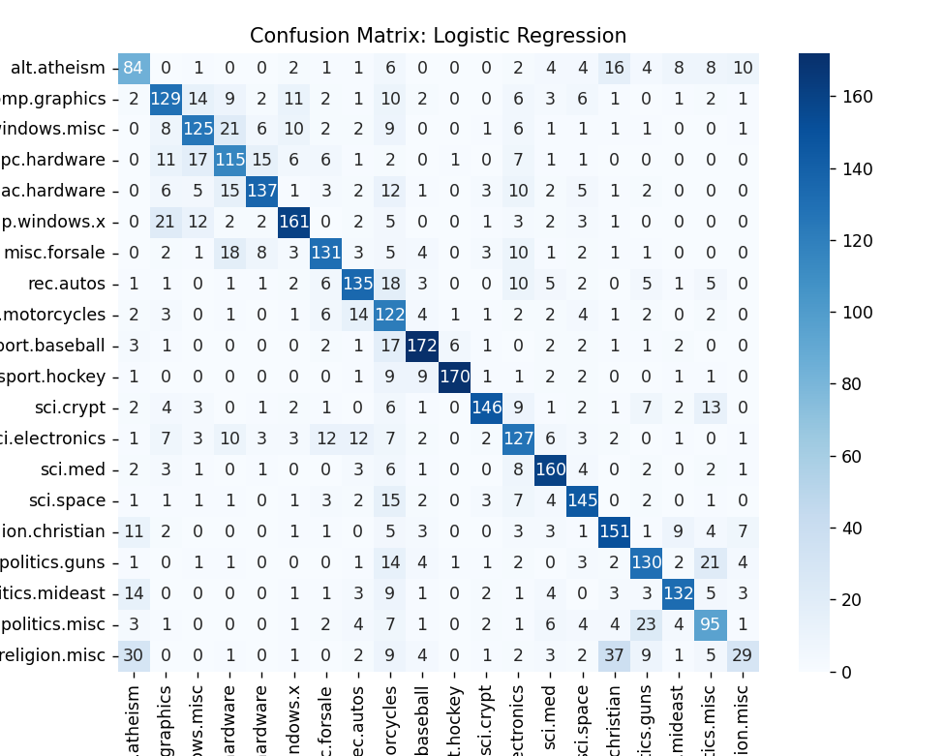

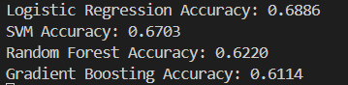



Задача 6. Определение типа стекла

Набор данных: Glass Identification Dataset на UCI Machine Learning Repository.

Предварительная обработка: масштабирование, разделение данных на обучающие и тестовые.

Модели: логистическая регрессия, SVM, k-ближайших соседей, случайный лес, градиентный бустинг.

Сравнение моделей: точность, матрица ошибок.

Изучение и подбор гиперпараметров: GridSearchCV или RandomizedSearchCV.

Визуализация: важности признаков, корреляционная матрица.

import pandas as pd

import numpy as np

import matplotlib.pyplot as plt

import seaborn as sns

from sklearn.model_selection import train_test_split, GridSearchCV, RandomizedSearchCV

from sklearn.preprocessing import StandardScaler

from sklearn.metrics import accuracy_score, confusion_matrix, classification_report

from sklearn.linear_model import LogisticRegression

from sklearn.svm import SVC

from sklearn.neighbors import KNeighborsClassifier

from sklearn.ensemble import RandomForestClassifier, GradientBoostingClassifier

url = "https://archive.ics.uci.edu/ml/machine-learning-databases/glass/glass.data"

column_names = [

    "Id", "RI", "Na", "Mg", "Al", "Si", "K", "Ca", "Ba", "Fe", "Type"

]

df = pd.read_csv(url, names=column_names, index_col="Id")

X = df.drop(columns=["Type"])

y = df["Type"]

scaler = StandardScaler()

X_scaled = scaler.fit_transform(X)

X_train, X_test, y_train, y_test = train_test_split(X_scaled, y, test_size=0.2, random_state=42, stratify=y)

log_reg = LogisticRegression(max_iter=1000, random_state=42)

log_reg.fit(X_train, y_train)

y_pred_log = log_reg.predict(X_test)

svm = SVC(kernel='linear', probability=True, random_state=42)

svm.fit(X_train, y_train)

y_pred_svm = svm.predict(X_test)

knn = KNeighborsClassifier(n_neighbors=5)

knn.fit(X_train, y_train)

y_pred_knn = knn.predict(X_test)

rf = RandomForestClassifier(n_estimators=100, random_state=42)

rf.fit(X_train, y_train)

y_pred_rf = rf.predict(X_test)

gb = GradientBoostingClassifier(random_state=42)

gb.fit(X_train, y_train)

y_pred_gb = gb.predict(X_test)

def evaluate_model(y_true, y_pred, model_name):

    print(f"=== {model_name} ===")

    print(f"Accuracy: {accuracy_score(y_true, y_pred):.4f}")

    print(classification_report(y_true, y_pred))

    cm = confusion_matrix(y_true, y_pred)

    plt.figure(figsize=(6, 4))

    sns.heatmap(cm, annot=True, fmt='d', cmap='Blues')

    plt.title(f"Confusion Matrix: {model_name}")

    plt.xlabel('Predicted')

    plt.ylabel('True')

    plt.show()

evaluate_model(y_test, y_pred_log, "Logistic Regression")

evaluate_model(y_test, y_pred_svm, "SVM")

evaluate_model(y_test, y_pred_knn, "KNN")

evaluate_model(y_test, y_pred_rf, "Random Forest")

evaluate_model(y_test, y_pred_gb, "Gradient Boosting")

param_grid_svm = {

    'C': [0.1, 1, 10],

    'kernel': ['linear', 'rbf', 'poly'],

    'gamma': ['scale', 'auto']

}

grid_svm = GridSearchCV(SVC(probability=True, random_state=42), param_grid_svm, cv=3)

grid_svm.fit(X_train, y_train)

print("Лучшие параметры для SVM:", grid_svm.best_params_)

param_dist_rf = {

    'n_estimators': [50, 100, 200],

    'max_depth': [None, 10, 20],

    'min_samples_split': [2, 5, 10]

}

random_rf = RandomizedSearchCV(RandomForestClassifier(random_state=42), param_dist_rf, n_iter=10, cv=3, random_state=42)

random_rf.fit(X_train, y_train)

print("Лучшие параметры для Random Forest:", random_rf.best_params_)

plt.figure(figsize=(10, 8))

sns.heatmap(df.corr(), annot=True, cmap='coolwarm')

plt.title("Корреляционная матрица признаков")

plt.show()

importances = rf.feature_importances_

indices = np.argsort(importances)[::-1]

features = X.columns

